Su Pyae Thu Ya

S1809320@connect.glos.ac.uk

 By 

**Usability or CIF Report for**

Table of Contents

1 Exclusive Summary 2

2 Introduction 3

2.1 Full Production Descriptions 3

2.2 Test Objective 5

3 Method 6

3.1 Participants 6

3.2 Context of Product Use in the Test 8

3.2.1 Task Scenario 8

3.2.2 Physical Test Environment 10

3.2.3 ICT Test Environment 10

3.2.4 Test Administrator Tools 11

3.3 Evaluation Study Design 11

3.4 Procedure 12

3.5 Participant Instructions 12

3.6 Usability Metric Employed 12

4 Result 13

4.1 Data Analysis 13

4.1.1 Data Scoring 13

4.1.2 Data Reduction 13

4.1.3 Statistical Analysis of Quantitative data 14

4.1.4 Analysis of Qualitative data 14

4.2 Presentation of the Results 14

4.2.1 Performance Results from Quantitative data 16

4.2.2 Analysis of Qualitative data 16

5 Appendices 18

Bibliography of resources for usability evaluation 18

Appendix 1 19

RESEARCH ETHICS: CONSENT FORM (Filled Sample) 19

RESEARCH ETHICS: CONSENT FORM (Blank Sample) 20

Appendix 2 21

Focus Group Instructions 21

Introduction 21

Guideline for Participants 21

Participant Instructions 21

Appendix 3 23

SUS: System Usability Scale Form (Filled Sample) 23

SUS: System Usability Scale Form (Blank Sample) 23

# Exclusive Summary

This report is about the usability test report of the coin transaction system, which is named Gone Sin Mal developed by Bit Geeks team, and 3 Focus groups are gathered to participate in testing 3 sides of the app, Customer side, Restaurant side and Admin side. Gone Sin Mal is targeted to those who want to gain benefits every time they go and eat at the restaurants and those restaurants that want to get more customers and developers that want to earn profits. The aim of this test is to know that whether the app is really appropriate for the users and that the app would work without breaking down or with no bugs.

There are altogether 18 participants and each of the participants are given a role (customer side, restaurant side or admin). With each role, a set of instructions are given to fulfill the tasks and complete the testing. Of all those 18 participants, there are people with little or no knowledge about technical things and there are also people who have quite a skill to complete all those tasks without having problems. All of the participants are that of students, staffs and faulty members of Gusto Collage.

Soon after the testing are done, discussion and feedback section was made and SUS form was handed out to get feedback on the app. The mean of the customer side SUS score is 89.5 and that of the restaurant side is 80.8 and 84.9 with the admin side (6 participants each) which means that the scores are above average and the app is in the right way. Based on some of the feedbacks from the participants during the discussion, it can be concluded that they have a good impression upon the product. One participant mentioned it as “foresighted” and “easy to use”. Some other even said that they would talk about this app to their friends and family when it is really on the market. Those who were assisted even provide that “even though there are some complicated matters, with assisting once, it become very easy to use”.

Some of the Improvements that were suggested by the participants are:

* The Map of the restaurant when registering should use a simple one instead of dragging the marker to the location of the restaurant.
* Pages that needed the authentication shouldn’t have to be authenticate all the time when it have to use. Should try other alternative like fingerprint scanning.
* Help icon should be in places with complicated functions like buying special coins, to provide information.
* Login ways shouldn’t be only just one type, with Facebook. Other choices like Google+ or Instagram is needed.
* Refund system should be automatic so that the admin don’t have to go and confirm it every time the restaurant want a refund.

# Introduction

## Full Production Descriptions

Gone sin mal is a coin currency system for customers that go and eat at the restaurants. It was developed by Bit Geeks team, consists of 6 members, each with their own roles, in 4 months. The product is divided into 3 sides, customer, restaurant, and admin. The test is being carried out for the all 3 sides of Gone Sin Mal to a 3 focus groups (6 people each). The test is about the participants being able to use the user interface that is provided as an examples of some screenshots in **Figure 1, 2, 3, 4, 5, 6** easily and conveniently.

The intention of this product is to be able to help any customers of the restaurants get benefits, vise vasa to the restaurants and admins as well, from eating there (except getting full from eating there). Users as customers would get their own collection of coins that would come in handy eating at any restaurants they like (for those which use the application only). Users from Restaurants can get coins and give them to customer based on their needs and can get new customers through it. Users of Admin side for managing coin flow and manage users. Hence, Gone Sin Mal aims for all of the people, mostly food lovers, with no limitation in ages, as long as they can go and eat at the restaurants (aging from 15 and above) and those restaurants (start-up as well) that want new customers or more customers (aging 18-60) and finally, the users of admin side (aging 18-60). As for the environment of Gone Sin Mal, it can be used as long as there is an internet connection and mobile phone, smart phone to use, both android and iOS are available.

The Food lovers can go and eat at any restaurants by opening account with their Facebook account (more convenient since almost all of the people use it) and collect enough coins to go and eat free at restaurants. Restaurants as well buy coins, give customers coins, get back from them, or refund those coins back to the admin side to get money back. Gone Sin Mal application lets the user as customers to create an account, collect coins from restaurants, get information about newly opened restaurants, save their favorite restaurants, edit their location, and get special coins for free, that is given by a particular restaurants that would be able to eat at low price there. User as restaurant can create an account, buy and refund coins with money, scan QR to give or take coins to customers, and edit profile. Lastly, User of admin can keep track of the coin status, remove or add admin, and refunding money for restaurants sold coins.

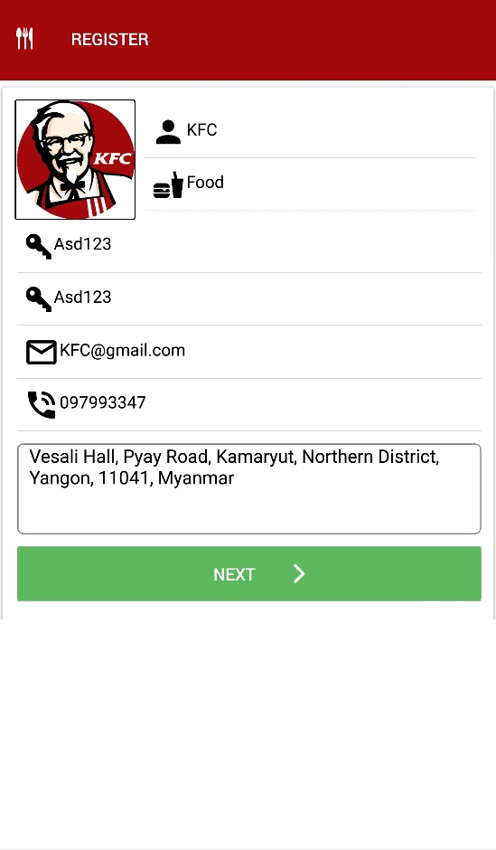

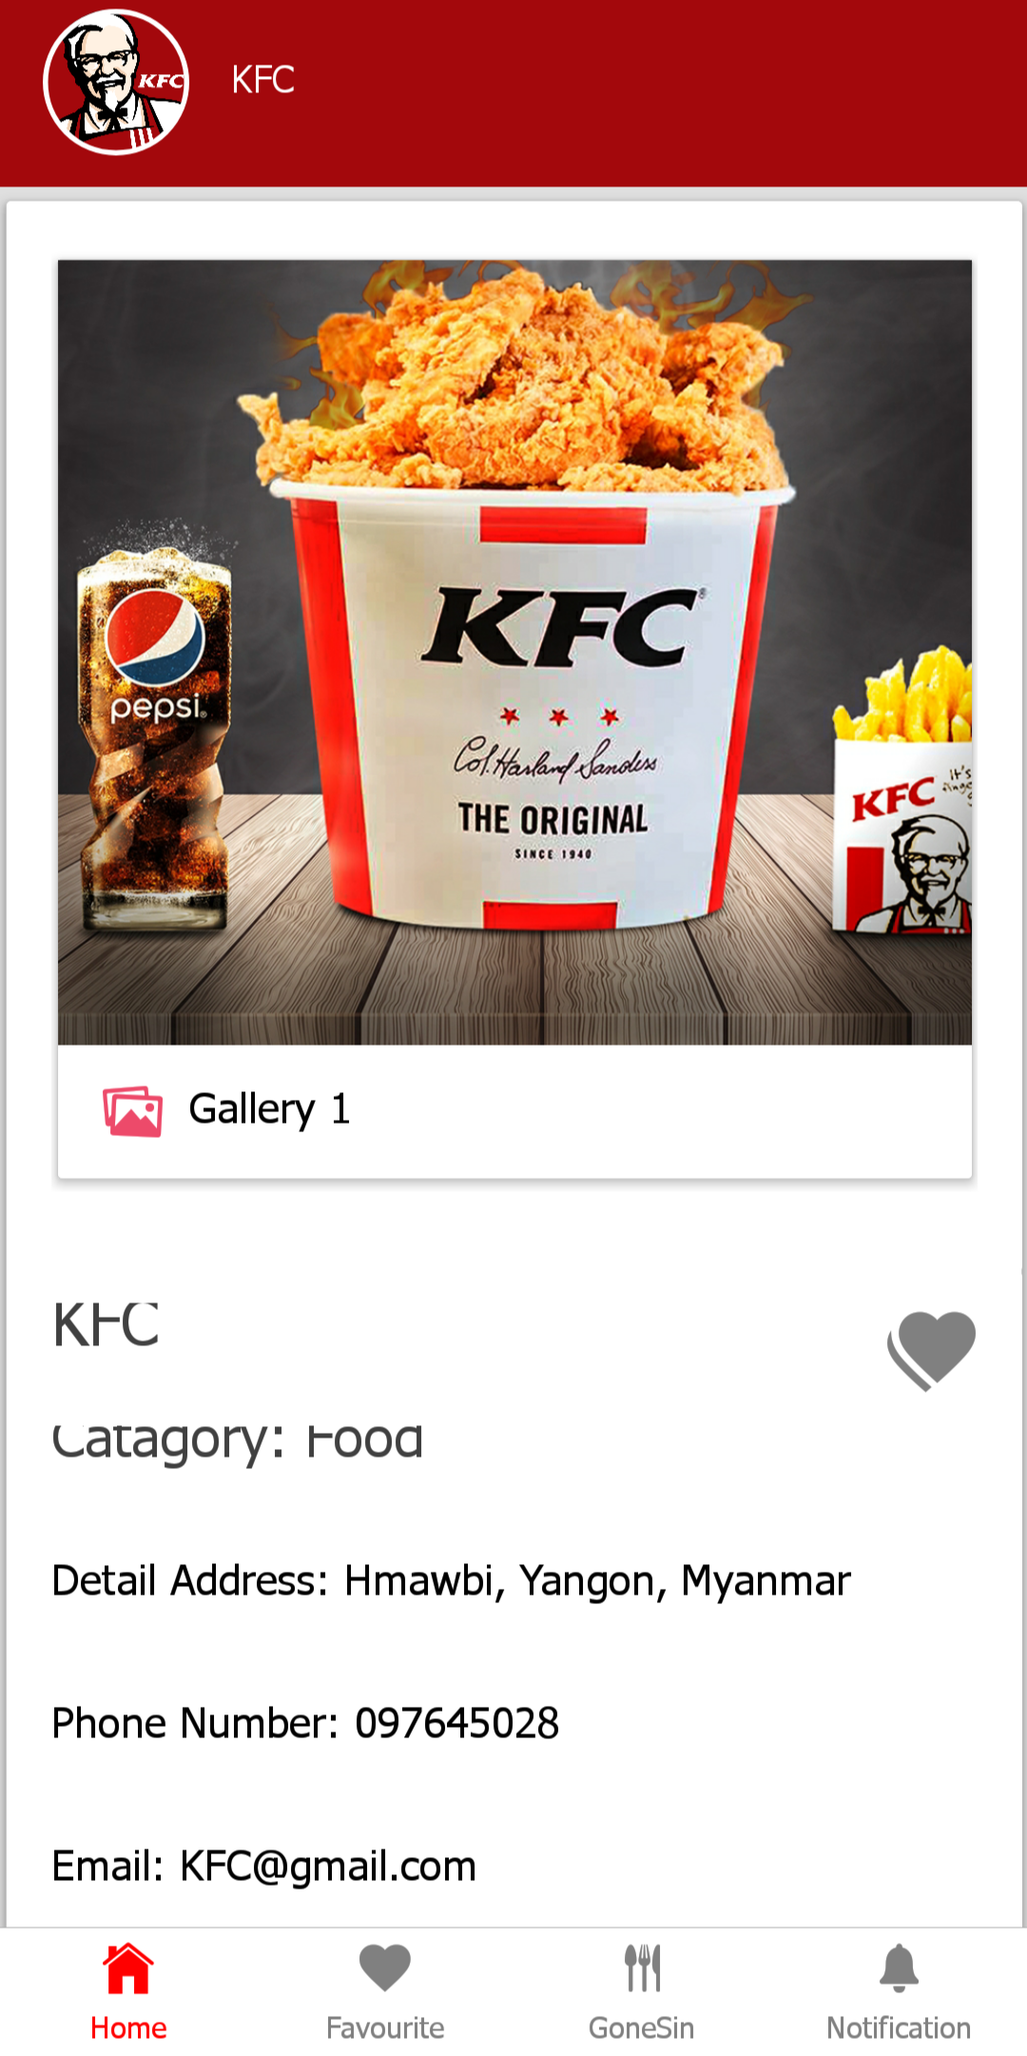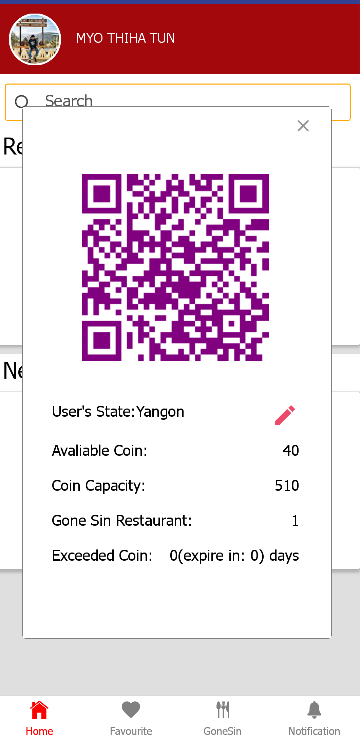

**Figure 1:** Restaurant page (Customer) **Figure 2:** Profile page (Customer) **Figure 3:** Register page (Restaurant)

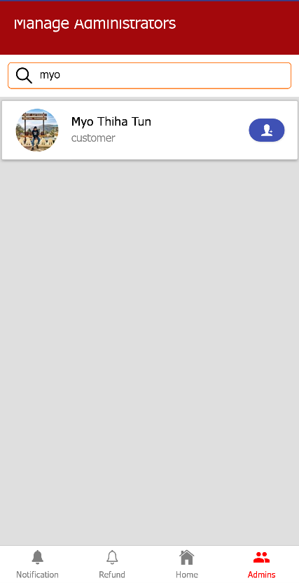

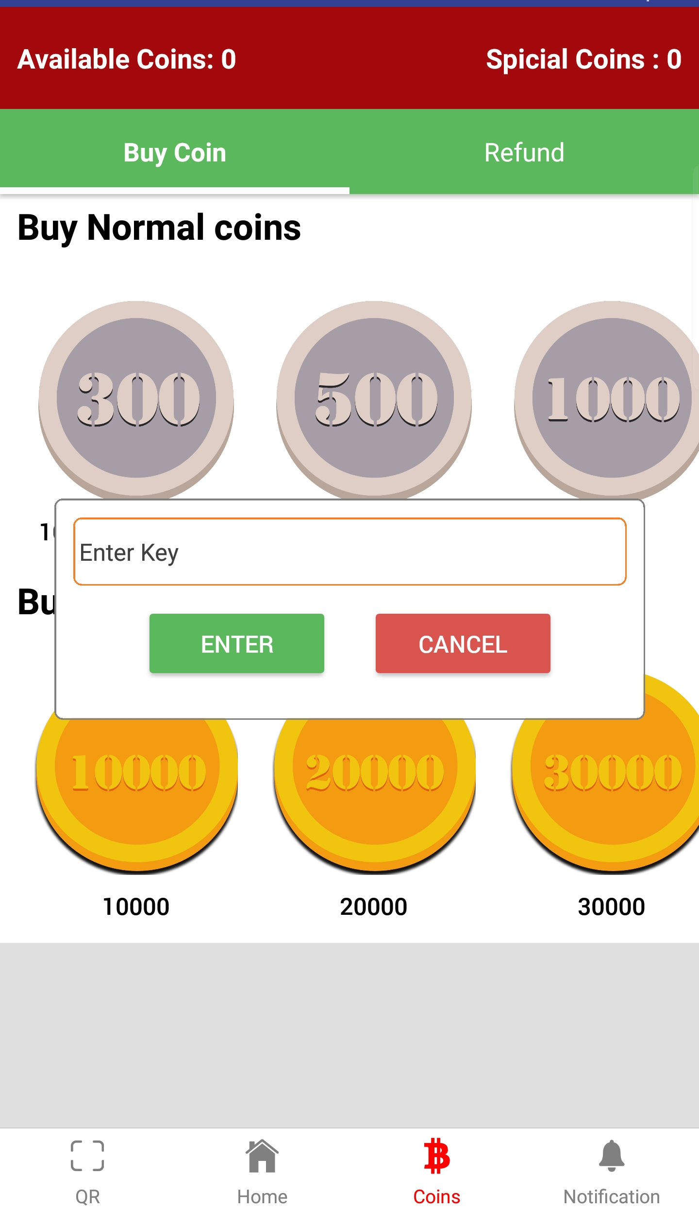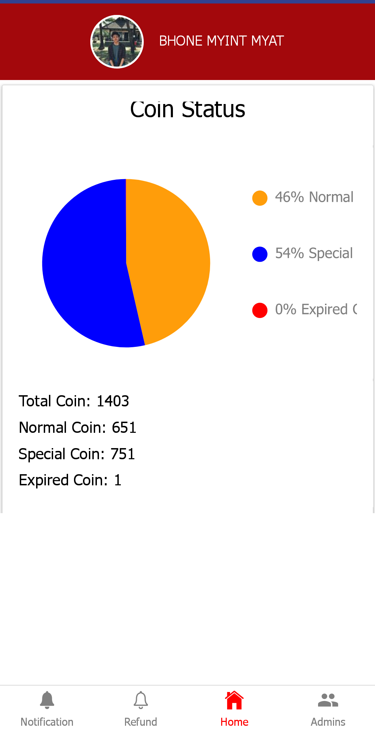

**Figure 4:** Coin page (Restaurant) **Figure 5:** Home page (Admin) **Figure 6:** Admin page (Admin)

## Test Objective

The primary objective of the test is to know whether there are any trouble using the application Gone Sin Mal. For instance, whether they are convenient, user-friendly or not. Since not all users have technical ability, user interface needed to be able to help users guide through things. Moreover, along the way of testing it, it could be helpful if there are any bugs or issues arising so that those can be fixed by our team before the product is in the hands of the actual users. Lastly, Feedbacks, that are attained from the on how the application could be improved furthermore is very important since it can be a helping hand when it comes to system being more robust and give satisfaction.

The functions and interface that will be tested by the participants are:

1. For customer side

* Create account with Facebook
* Edit location using Expo map view
* Saving restaurant information as Favorite
* Looking into Restaurant Detail page
* Getting Gone Sin Mal special to go and use at that particular restaurant

1. For restaurant side

* Sign up account by inserting, picture, name, restaurant category, password, email, phone number and address.
* Editing restaurant page by inserting images in gallery, editing location, email, phone, and category.
* Inserting amount to give or take from customers and scan the QR code of customers.
* Buy or refund coins, from and to admins.
* Buying special coin and provide how many users to send out those coins by inserting number of users and transaction ID from MyanPay in Notification page “Confirmation notification”.
* Entering password in all of the pages (except home page)

1. For Admin side

* Searching, adding user to become admin and removing them.
* Keeping track on coin status
* Confirming Refund request
* Entering password in all of the pages (except home page and notification page)

# Method

## Participants

Gone Sin Mal is being tested by total of 18 participants, ages vary from 15 and above, and each of the 6 participants are separated into 3 focus groups. The first focus group is for testing customer side, second group for restaurant, and the last focus group is for admin side. More than half of the participants in those 3 focus group are students from Gusto collage. So, even though they might not be highly skilled, at least they know about technical things and can properly use an applications. The other half of the participants are those from Gusto but with no technical experience unlike those of those students. With no previous experience in using Gone Sin Mal coin transaction system, all of those participants are being tested. The only difference between the participants for testing restaurant and admin side and the actual users is that, the actual users will be trained for how to use it since there might be a bit complication upon using it.

|  |  |  |  |  |  |  |  |
| --- | --- | --- | --- | --- | --- | --- | --- |
|  | Gender | Age | Education | Occupation / role | Coin Logic System Experience | ICT  Experience | Gone Sin Mal Experience |
| Participant 1,Group 1 | Male | 22 | Undergraduate | Student | Medium | Medium | Novice |
| Participant2, Group 1 | Male | 20 | Undergraduate | Student | High | High | Novice |
| Participant3, Group 1 | Female | 30 | Graduate | Receptionist | Low | Medium | Novice |
| Participant4, Group 1 | Female | 16 | Undergraduate | Student | Low | Medium | Novice |
| Participant5, Group 1 | Female | 25 | Graduate | Receptionist | Medium | Low | Novice |
| Participant 6, Group 1 | Female | 38 | Graduate | Faculty Member | High | High | Novice |
| Participant7, Group 2 | Female | 30 | Graduate | Faculty Member | High | High | Novice |
| Participant8, Group 2 | Male | 16 | Undergraduate | Student | Medium | High | Novice |
| Participant9, Group 2 | Male | 21 | Undergraduate | Student | High | Medium | Novice |
| Participant10, Group 2 | Female | 28 | Graduate | Student affair staff | Low | Low | Novice |
| Participant 11, Group 2 | Female | 20 | Undergraduate | Student | Medium | Medium | Novice |
| Participant12, Group 3 | Male | 18 | Undergraduate | Student | High | Medium | Novice |
| Participant13, Group 2 | Male | 15 | Undergraduate | Student | Medium | Low | Novice |
| Participant14, Group 2 | Male | 35 | Graduate | Faculty Member | High | High | Novice |
| Participant15, Group 2 | Male | 25 | Graduate | Office staff | Medium | Low | Novice |
| Participant 16, Group 2 | Male | 15 | Undergraduate | Student | Low | Medium | Novice |
| Participant 17, Group 2 | Female | 27 | Graduate | Student affair staff | Low | Low | Novice |
| Participant 18, Group 2 | Female | 20 | Undergraduate | Student | High | High | Novice |

**Table 1:** Characteristics of the participants

## Context of Product Use in the Test

### Task Scenario

All of the participants were constructed too achieve or fulfill the tasks instructions provided as follows.

All Participants must:

* Install the Apk file for those who have an android phone, and QR code for those who have an iOS phone (iOS users need to install Expo firstly).
* Each participants must use according to the role that they are provided. (those as a customer for customer side app, those as restaurant staff for restaurant side, and those who have to manage those sides as admin side)

For participants testing customer side (1st focus group):

* Login with Facebook account.
* Go to user profile page by clicking the profile picture.
* Edit location of the user.
* Search the restaurant by name (will show that restaurant if it is in the database and if not, then show “No search Found”).
* Go to restaurant page, in order to be able to look at more information like Food category, Address, Phone Number, Email.
* Swipe right on gallery to look at more at the pictures of that restaurant.
* Look at the location of the restaurant on map view.
* Add Favorite and go to favorite page to know whether it is mark as favorite or not
* Click Gone Sin tab to use the coins by clicking the coins button.
* Feel free to test around as they like.

For participants testing restaurant side (2nd focus group):

* Register by inserting all of the text fields and click next.
* Edit each and every field after being registered. (Gallery, Category, Email, Phone number, Location)
* Go to coins page and buy and refund normal coins.
* Buy special coins and go to notification page to complete the process.
* Give or take coins from customer.
* Feel free to test around as they like.

For participants testing admin side (3rd focus group):

* Key inserting as soon as logging in with Facebook and Key will be provided by our team.
* Enter key in order to login to pages except notification and home page.
* Search users to add as admin.
* Complete refund request after money transaction is done.
* Feel free to test around as they like.

All of the tasks that are provided above covers all of the functions of the coin transaction between customer and restaurant, and restaurant and admin. Additionally, all of those functions will be used in daily basic for each user sides but some might not (like editing profile). During those task, the participants will be monitored to make sure that the testing done by the participants are completed one step at a time.

### Physical Test Environment

The testing was conducted in the UOG Classroom at Gusto Collage and the sounds of the surrounding can’t be heard much at all (was able to conduct with ease without destructions). The temperature of the classroom was adjusted according to the temperature (neither cold nor hot). Participants of all 3 focus groups are placed altogether in one room and tables and chairs are provided for them to get through the test comfortably. For those who mobile phone version need to be updated (12.1 and above for iOS), smart phones are provided. Devices like projector and laptops are presented for showing instruction guide and scanning QR for iOS devices.

### ICT Test Environment

The following table shows that the software and operating systems that are being used by each participant when carrying out the provided tasks with mobile phones.

|  |  |  |
| --- | --- | --- |
| **Participant Number:** | **Operating System Used:** | **Gone Sin Mal App Used:** |
| 1 | Android 8.0.0 | Apk file |
| 2 | iOS 12.1 | Expo app and QR scanned |
| 3 | Android 8.0.0 | Apk file |
| 4 | iOS 12.1 | Apk file |
| 5 | Android 8.0.0 | Apk file |
| 6 | Android 8.0.0 | Apk file |
| 7 | iOS 12.1.3 | Expo app and QR scanned |
| 8 | Android 8.0.0 | Apk file |
| 9 | iOS 12.1 | Expo app and QR scanned |
| 10 | Android 8.0.0 | Apk file |
| 11 | iOS 12.1.3 | Expo app and QR scanned |
| 12 | Android 8.0.0 | Apk file |
| 13 | Android 8.0.0 | Apk file |
| 14 | Android 8.0.0 | Apk file |
| 15 | iOS 12.1 | Expo app and QR scanned |
| 16 | iOS 12.1 | Expo app and QR scanned |
| 17 | Android 8.0.0 | Apk file |
| 18 | Android 8.0.0 | Apk file |

**Table 2:** ICT Test Environment

Noted: Below iOS version 12.1 don’t have scanner function in camera so won’t be able to use the app.

### Test Administrator Tools

System Usability Scale (SUS) is being used and samples are provide in **Appendix 3**. After the application is being tested with the participant’s own smartphones, SUS questionnaires were handed out to be fill with care and thinking each questions hardly.

## Evaluation Study Design

The process of carrying out the testing group is as follows:

1. Participants were asked to take palace in the room and get comfortable.
2. Researchers greeted all of the participants and Introduce one by one to the participants. Then, researchers let the participants introduce themselves.
3. Researcher introduced the purpose of the testing, why it is being held and how every little step that is going to be made here is important.
4. After that, Researcher asked about whether the participants knew about the coin currency system for restaurants and what do they know about it. For those who don’t know about it were explained by the researcher.
5. Participants were asked to fill the “Research Ethics Consent Form” that is on the table in front of them (which was already prepared by the researchers before the participants come in) as shown in **Appendix 1**.
6. Researchers make sure that all of the Forms are completed properly.
7. Researchers then given a role to each participants and provide a set of Guidelines verbally and through the projector as provided in **Appendix 2**.
8. Researchers begin the test by showing the Instructions with the projector (**Appendix 2**).
9. Researcher conducted the Discussion section where the participants can asked questions and provide feedback on the app (**Appendix 2**)
10. Hand out the SUS paper to fill out (**Appendix 3**) and thank the participants for their time to help us out on the testing.

Participants detailed information were not asked (phone number, address, hobbies and so on) since it is not needed and some of the papers were transferred into digital for better keeping.

## Procedure

All of the participants were neither paid nor compensated since all of them are willingly to join. As for the selection of the participants, all of them are selected randomly to get a mixture of people with different technical ability. Researchers have treated all of the participants equally with no biased and conduct a fair test for each and every one of them. Each and every guidelines, instructions, tasks, forms that are provided in **Appendix 1 and 2** are worked through one after another in sequence and even though the verbal introductions, discussions and feedbacks might not be exactly the same, it still provide the same meaning (**Appendix 2**). With no limitation in time and no prior training, the participants set out to do the test which could provide the information of whether the app is usable enough or not. For each of the Focus group, 2 researchers are assigned including the researcher who led this research.

## Participant Instructions

As provided detailed in **Appendix 2,** the summary of the instructions are:

* Introducing one by one
* Fill out the form that have hand out by the researchers
* Follow the set of guidelines and instructions when testing
* Provide Feedback and discussion after the test
* Fill out another form after testing

## Usability Metric Employed

**Effectiveness:** is measured by whether the participants succeeded in completing the tasks with or without the assistants of the researchers.Even though some of the participants needed to be assisted when following some of the instructions although most of the participants weren’t, all of the participants successfully completed the instructions for the tasks. The main problem that need to be assisted is to those who test for the restaurant side, where they wasn’t able to move the marker on the map and also there are some of those who were a bit complicated due to coin buying. With this measurements, some to the interface could be changed (like inserting popped up instruction guides when using) but due to most users, the UI are foolproof.

**Efficiency:** The time for the participants were not limited but due to some records that have been taken, the participants of the admin side testing finished within 15 minutes with the shortest time since there are not much functions there and customer side with 25 minutes and the longest of them all is the restaurant side, finishing all of the tasks with 45 minutes. For the rest of the tasks, Introduction and Research Ethics Form with 20 minutes, Reading Guidelines and Task instructions with 25 minutes all together, Discussion and feedback section with 5 to 10 minutes, and lastly, SUS form with 5 minutes.

**Satisfaction:** Based on some of the feedbacks from the participants during the discussion, it can be concluded that they have a good impression upon the product. One participant mentioned it as “foresighted” and “easy to use”. Some other even said that they would talk about this app to their friends and family when it is really on the market. Those who were assisted even provide that “even though there are some complicated matters, with assisting once, it become very easy to use”.

The mean of all the SUS scores that are being calculated for each Focus Groups as shown above in **Figure 7, 8, 9** are 89.5, 80.8 and 84.9 each, where all of those means are near to 100 (which means that all of the means are above average) so one can conclude that the app is in the right way.

# Result

## Data Analysis

### Data Scoring

#### Quantitative Data

Sample of the SUS form where data being gathered can be seen in **Appendix 3** and the score of all those participants were calculated, averaged and transfer into a chart to get the clear view of the scores (**Figure 7,8,9**).

#### Qualitative Data

Data were scored based on the discussions and feedbacks that are provided by the participants during the discussion section.

### Data Reduction

Data Reduction was not necessary.

### Statistical Analysis of Quantitative data

With the help of SUS, all of the data were transfer from the paper to Microsoft excel. Then, the scores are calculated as it was instructed (excel was being set up to calculate automatic). Finally, after all of those 18 participants scores are done calculating, the mean was being calculated and shown in chart.

### Analysis of Qualitative data

With the help of other researchers, all of the data have been gather by taking notes (even though the discussions are not exactly the same, it still has the same meaning). Some of the discussion are provided under “4.2.2 Analysis of Qualitative data”.

## Presentation of the Results

The charts below are for showing the scores and means off the data that are gathered from the 18 participants of 3 Focus Groups (6 participants each). On the first chart, Focus Group 1 of the customer side testers have a minimum SUS score of 80 with the maximum of 100, along with mean score of 89.5. However, in second chart for restaurant side, the minimum score is 70 and that of the maximum is 90 where the mean score is 80.8. Lastly, for admin side as shown in the third chart, the mean score is 84.9 with maximum 100 and minimum 72.5.

**Figure 7:** Focus Group 1: SUS Score chart (Customer Side)

**Figure 8:** Focus Group 2: SUS Score chart (Restaurant Side)

**Figure 9:** Focus Group 3: SUS Score chart (Admin Side)

### Performance Results from Quantitative data

Although there are some participants that need the assistance, most of the participants have done quite well on all of the tasks based on their technical skills and experience in using coin transaction system or other similar systems as provided in **Table 1**.

The mean of all the SUS scores that are being calculated for each Focus Groups as shown above in **Figure 7, 8, 9** are 89.5, 80.8 and 84.9 each, where all of those means are near to 100 (which means that all of the means are above average) so one can conclude that the app is in the right way.

### Analysis of Qualitative data

Qualitative data was provided based upon the discussions and feedbacks of the participants from 3 of the focus groups with different backgrounds. The section of discussion is conducted after finished testing and most of the participants have given their opinions and feedbacks but there are some that didn’t participate (might be nervous or just don’t have to provide anything). The chapter below is about the discussion about the app between the participants and the researcher.

***Researcher 1: What did you guys think about the app, Gone Sin Mal? Was it easy to use?***

Participant 9 and 10 provided that when registering the restaurant, it was a hard time moving the location in the map since all they know is to go to the location and point that location to get the address. However, in this one, they need help since it can’t be done for a long time. Later, after the researcher showed them how to do it, they just know about it than that they have to drag the pointer.

***Participant 10:*** *Participant 9 is right. I, too, stuck at that place and don’t know what to do next. I tried touching the marker and touch the location but it didn’t work. So, it would be nice if u guys change that to something simple.*

Participant 18 raised an opinion about the admin side where the key have to be typed in every time when participant 18 wants to go to that coin refund page and admin managing page. Alternative authentication, which is not that bothersome should be added in this place.

***Participant 10:*** *Yeah, yeah. In restaurant side too, there are some page that have to put in the password every time I want to use that page. If possible, I just want to open it with my fingerprint or something. So that I don’t have to type in the password every single time.*

Some participants suggest that it would be much better if some of the places have help icon and provide information when clicking it.

***Participant 7:*** *I agreed on that one. When I was buying the special coin, I didn’t know I have to go to the notification page for the special coins purchase to be done. Also, I don’t know what to do next when the MyanPay page popped up. A help sign with information provided about the respective function would assist better for the app.*

Despite those issues, participants are mostly happy about using the Gone Sin Mal App.

***Participant 2****: Well, as for me, I enjoyed testing this app and looking forward to seeing it on market soon.*

***Participant 3:*** *Thank you for inviting me to this testing event. The app was really cool and easy to use.*

***Participant 9:*** *Guess it was easy to use after all. Just that little map problem and the rest was great. Nice idea guys.*

***Participant 10:*** *Except that map problem, everything else was ok.*

***Participant 14:*** *Great work everyone. Creative app and I would like to use it every day.*

***Participant 18:*** *is pretty clear and like the design of it. Red is a good color choice.*

***Researcher 1: What kind of improvements should be made in Gone Sin Mal?***

One participant said that there should be another choice to log in the app like Google+ or something. Login type shouldn’t be just one.

***Participant 1:*** *I would like to suggest that there should be more than one login type. Like with Instagram, Google+ or some other that one can login with one or another type of social media.*

Participant 16 suggests that the payment method should be change or add some other payment systems since Myanpay could be only paid manually and it is pretty complicated. Therefore, some other methods should be included there.

***Participant 16:*** *The payment system is really complicated. I have to go to myanpay page, make an account, and do the payment process but I have to go and look at the email to confirm the transaction process. Key was being provided….Ughhhhhhhhhh… I definitely don’t want that kind of stress. It would be nice if there are more kind of payment with, KBZ, CB Bank, Visa or others.*

Some of the participants included that there should be automatic refund process so that people won’t have to go to that page every time someone have refunded the coins. If there are thousands of customers, there wouldn’t be enough admin or even if there are many admins, it would be a waste of time just confirming the refund process.

***Participant 17:*** *The refund process was very tiring.*

***Participant 18:*** *True. If I were to be the developer, I would just make it automatic for the process since it is pretty tiring.*

***Participant 14:*** *I agreed on that one. You guys should make it automatic.*

# Appendices

## **Bibliography** of resources for usability evaluation

Anon., 1999. *How to write a Usability Report in the CIF format: for use in the University of Gloucestershire,* s.l.: MU/IGD Course team.

Barnes, C., Dinan, J. & Vines, J., 2017. *CIF Usability Report for Digisign by Nova software,* Gloucestershire: s.n.

# Appendix 1

## RESEARCH ETHICS: CONSENT FORM (Filled Sample)

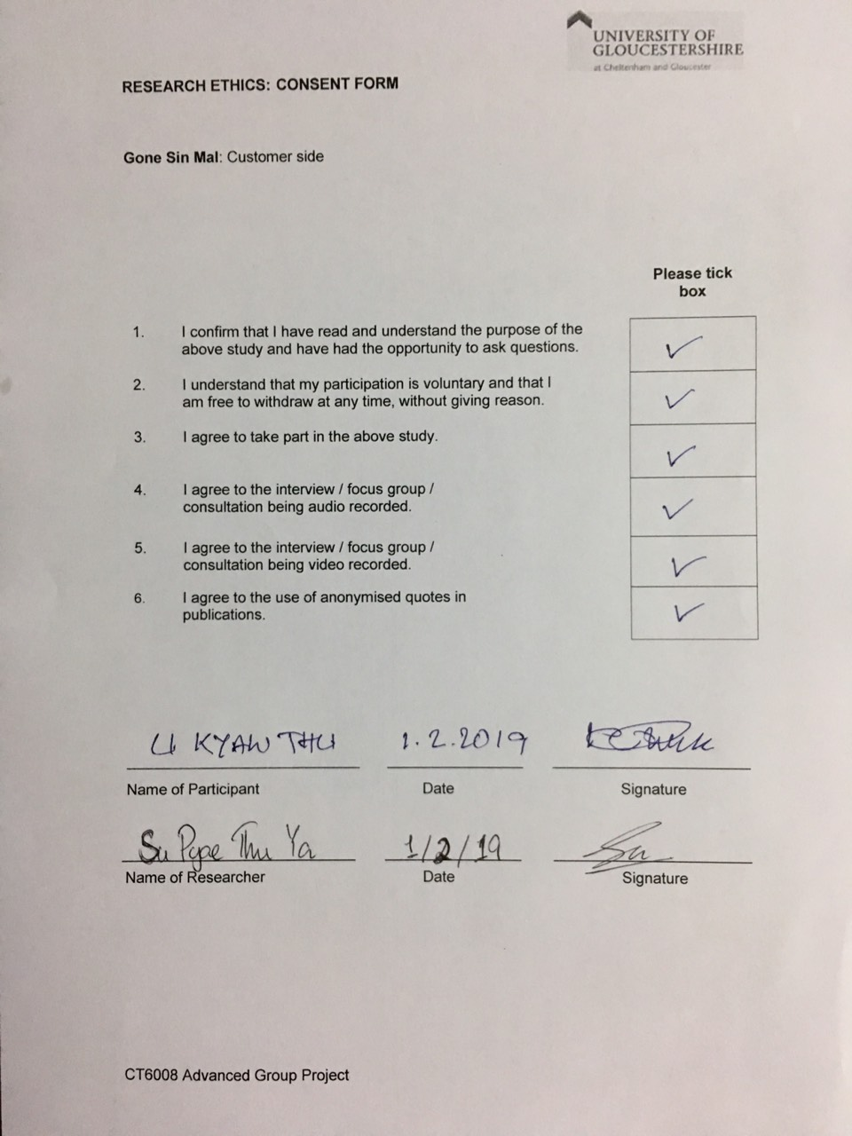

## RESEARCH ETHICS: CONSENT FORM (Blank Sample)

**Gone Sin Mal**: Customer side

|  |  |
| --- | --- |
|  | **Please tick box** |
| 1. I confirm that I have read and understand the purpose of the above study and have had the opportunity to ask questions. |  |
| 1. I understand that my participation is voluntary and that I   am free to withdraw at any time, without giving reason. |  |
| 3. I agree to take part in the above study. |  |
| 4. I agree to the interview / focus group / consultation being audio recorded. |  |
| 1. I agree to the interview / focus group / consultation being video recorded. |  |
| 1. I agree to the use of anonymised quotes in publications. |  |

Name of Participant Date Signature

Name of Researcher Date Signature

# Appendix 2

## Focus Group Instructions

## Introduction

Welcome everyone, today we would like to thank you all for joining us. I am su pyae thu ya, the lead researcher and this is, yune nadi oo, aung phone kyaw, khant ti kyi, myo thiha tun and min thu khant, who will be assisting you throughout this secession. First, you have to introduce about our app, Gone Sin Mal.

Does anyone know about Coin or points system?

As some of you might know about City Mart reward, just like that app, our app is based on a coin currency system where users can go and eat at restaurants and get coins after eating. Win-Win, right.

Not only customers, restaurants can also get more customers through this app and people who have developed can profit by selling the coins and refunding it at low price.

Therefore, in order to test this app, I need your help. As you can see on the desk, the Research Consent forms are provided for you to fill out and sign.

After finished filling out, I will continue by giving you a set of guidelines and instructions through this projector and by me.

At the end of the testing, there will be a discussion section where everyone can participate to give us your thoughts about the app. We won’t bite you so feel free to suppress your thoughts.

Finally, we will end by giving you feedback forms to fill in.

Does anyone have questions on what I have said? If not, let’s start.

## Guideline for Participants

* First of all, please provide your names so that we address you.
* When testing, please be as quiet as you can so that you won’t disturb other people.
* When discussing, please take one by one so that we would be able to give you a clean answer.
* Please participate in discussions and give us both positive and negative opinion on the app.
* Every participant must respect each other ideas.

## Participant Instructions

All of the participants were constructed too achieve or fulfill the tasks instructions provided as follows.

All Participants must:

* Install the Apk file for those who have an android phone, and QR code for those who have an iOS phone (iOS users need to install Expo firstly).
* Each participants must use according to the role that they are provided. (those as a customer for customer side app, those as restaurant staff for restaurant side, and those who have to manage those sides as admin side)

For participants testing customer side (1st focus group):

* Login with Facebook account.
* Go to user profile page by clicking the profile picture.
* Edit location of the user.
* Search the restaurant by name (will show that restaurant if it is in the database and if not, then show “No search Found”).
* Go to restaurant page, in order to be able to look at more information like Food category, Address, Phone Number, Email.
* Swipe right on gallery to look at more at the pictures of that restaurant.
* Look at the location of the restaurant on map view.
* Add Favorite and go to favorite page to know whether it is mark as favorite or not
* Click Gone Sin tab to use the coins by clicking the coins button.
* Feel free to test around as they like.

For participants testing restaurant side (2nd focus group):

* Register by inserting all of the text fields and click next.
* Edit each and every field after being registered. (Gallery, Category, Email, Phone number, Location)
* Go to coins page and buy and refund normal coins.
* Buy special coins and go to notification page to complete the process.
* Give or take coins from customer.
* Feel free to test around as they like.

For participants testing admin side (3rd focus group):

* Key inserting as soon as logging in with Facebook and Key will be provided by our team.
* Enter key in order to login to pages except notification and home page.
* Search users to add as admin.
* Complete refund request after money transaction is done.
* Feel free to test around as they like.

# Appendix 3

## SUS: System Usability Scale Form (Filled Sample)

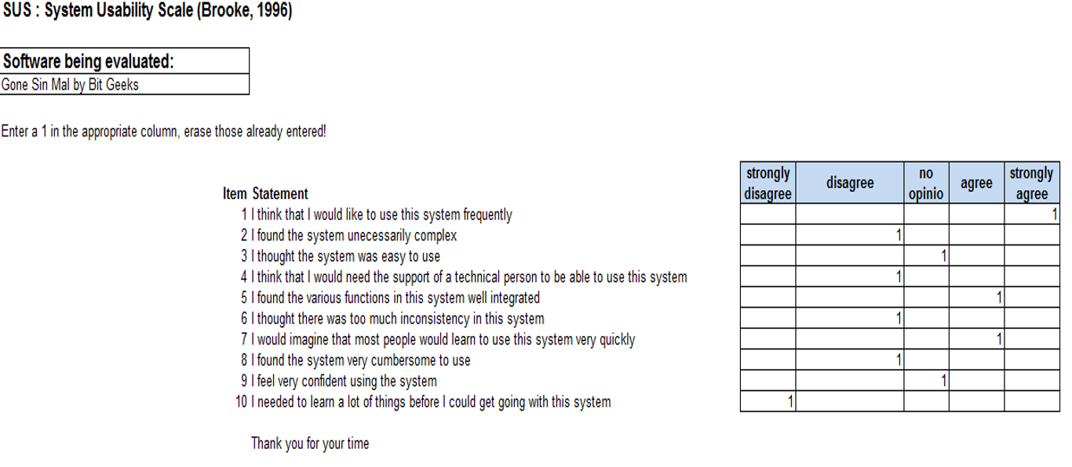

## SUS: System Usability Scale Form (Blank Sample)

